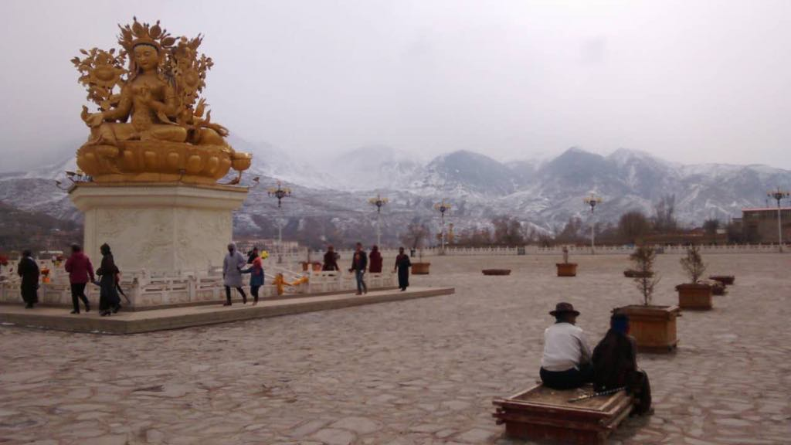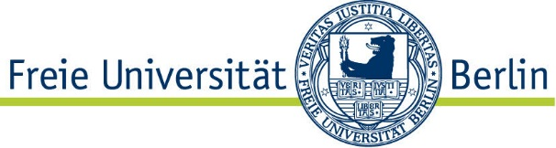

**Dienstag, 8. Mai**

**18.00 c.t.**

**Holzlaube 1.2001**

**Language and migrations from Central Tibet: language contact and ethnogenesis in the Wutun community (Amdo Tibet, Qinghai, People’s Republic of China)**

**PhD. Giulia CABRAS**

**(Guestresearcher / DaaD – Scholarship holder)**

**The term Wutun refers to a small language community settled in a rural area located  
in Tongren county (Ch. 同仁 Tóngrén, WT Reb gong, Amdo Tibet, current   
Qinghai province, People’s Republic of China). Even though officially classified as   
the Mongolic-speaking Tu (土 tù), Wutun speak a Sinitic language strongly influenced by Tibetan (called by the community ngandehua ‘our language’), and identify themselves as Tibetans.**

**In contrast to what is said by academic sources and Chinese official discourse, that see   
Wutun as the descendants of Sitinic garrisons, Wutun affirm that their ancestors,   
as well as their language have origins in Central Tibet. Through the   
community’s claims about the origins of the Wutun village as well as linguistic data,   
this seminar explores dynamics of identity construction as well as the linguistic   
and cultural maintenance of the community.**

**Fachbereich Geschichts- und Kulturwissenschaften**

**Institut für Turkologie**

**lädt herzlich ein zum Gastvortrag**